**CHAPTER 1**

|  |  |
| --- | --- |
|  |  |

**INTRODUCTION**

The Tours and Travel Website is a web based application. The main purpose of “Tours and Travels Website” is to provide a convenient way for a customer to book tour packages. The objective of this project is to develop a system that automates the processes and activities of a travel agency. In the present system a customer has to approach various agencies to find details of places and to book tickets. This often requires a lot of time and effort. We provide approach skills to critically examine how a tourist visits and its ability to operate in an appropriate way when dealing with the consequences of tourism, locally, regionally, and nationally including visitor security and ecological influences. It is tedious for a customer to plan a particular journey and have it executed properly. The website is developed to replace the currently existing system, which helps in keeping records of the customer details of destination as well as payment received.

* 1. **Motivation**

We know that in recent times, people like to visit different places. Tours and Travel website will help in accessing the information related to the travel to the particular destination with great ease.

**1.2 Objective**

The main objective of the Tours and Travel website is to manage the details of Tour packages, Phone no., E-mail ID, Tour Booking and Customer Support. The purpose of the project is to build a web application to reduce the manual work for searching the tours, Tours packages, customer queries etc. It tracks all the details about the booked package of customer.

**CHAPTER 2**

|  |  |
| --- | --- |
|  |  |

**SOFTWARE REQUIREMENT ANALYSIS**

**2.1 Introduction to Software**

**2.1.1 Web Browser**

A web browser, or simply "browser," is an application used to access and view websites. Common web browsers include Microsoft Internet Explorer, Google Chrome, Mozilla Firefox, and Apple Safari.

The primary function of a web browser is to render HTML, the code used to design or "mark up" web pages. Each time a browser loads a web page, it processes the HTML, which may include text, links, and references to images and other items, such as cascading style sheets and JavaScript functions. The browser processes these items, then, renders them in the browser window.

**2.1.2 Visual Studio Code**

Visual Studio Code is a lightweight but powerful source code editor which runs on your desktop and is available for Windows, MacOS and Linux. It comes with built-in support for JavaScript, Typescript and Node.js and has a rich ecosystem of extensions for other languages (such as C++, Java, Python, PHP and Go) and runtimes (such as .NET and Unity).

Visual Studio Code is an editor first and foremost, and includes the features you need for highly productive source code editing. This topic takes you through the basics of the editor and helps you get moving with your code.

**2.2 Modules & Its Functionalities**

**2.2.1 Signup Module**

We have made a Sign Up section which comes when clicked on the Sign Up option given in the navigation bar at the top ,a little of animation is used to show the contents of Sign Up . User gets certain benefits when signing in as then only user can book the tours package. There are four fields in Sign Up form which user has to fill in order to sign in and by the use of regex through JavaScript, it is made sure that user enters genuine values.

On signing in new page loads where there are no options of Sign Up and Login and there is a new option of tour package and a logout option.

**2.2.2 Login Module**

Made a Login Form which comes when user clicks on the Login Option in the navigation bar, On correctly entering the username and password, user is redirected to the Logged In page where he/she can see his username on the front page of website.

**2.2.3 Tour Package Module**

In this Tour Package module, We have added five types of tour as a prototype as to what tour package will look like, User can directly reach the tour package by clicking on the Tour Package option provided in the Navigation Bar after user has logged in on the website.

The five categories of tour are Popular Asian Destination, Popular Beaches, Popular Hill Stations, Trending Holiday Destinations and Trending Indian Places.In these categories we have placed some places from which user will select where he wants to travel.On clicking on any page user will reach the destination page to book a tour.

**2.2.4 Booking Module**

In this module, user can book a specific tour. In this page user will be given information about our tour to a particular place with the details of hotels in which he will stay during tour and the flights included in his tour. User have to provide the details from which date he wants to travel and upto which. He will also provide how many persons are travelling i.e no. of adults and no of children.

This section will not be visible to the normal visiting users but to only those who are logged in and that too when they click on the particular tour package to Book Now and then will be visible afterwards.

**2.2.5 About Us Module:**

In this module, Information about the site is given as well as the terms and policies and some other information, User can reach this section by either scrolling or by clicking on the About Us option given in the Navigation Bar.

**2.5.8 Main Page Module:**

The main page which will be visible to every visiting person and this contains all the other sections directly or indirectly, It has Navigation Bar at the top , then there is animated text order which is also animated and then there is portion of trending destinations and at last we have a about us section

**CHAPTER 3**

|  |  |
| --- | --- |
|  |  |

**SOFTWARE DESIGN**

## 3.1 Data Flow Diagram

It is a diagram of Authentication process which is a part of our project. In it user will enter his/her information to register, if the account already exists he/she will be able to do login directly without doing registration.

**3.1.1 Zero Level DFD**

It is also known as context diagram. It’s designed to be an abstraction view, showing the system as a single process with its relationship to external entities. It represents the entire system as single bubble with input and output data indicated by incoming/outgoing arrows.

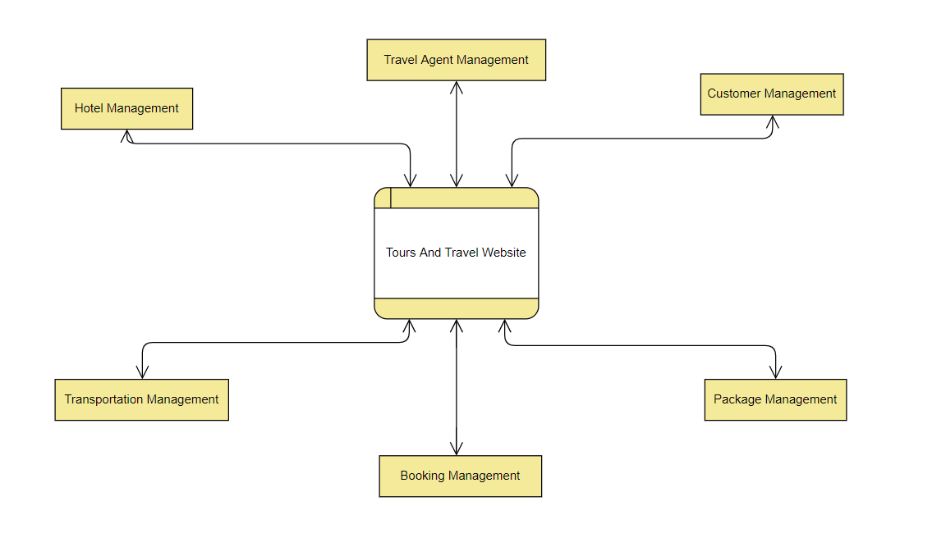

Figure 3.1 Zero Level DFD

**3.2 ER Diagram**

An Entity Relationship (ER) Diagram is a type of flowchart that illustrates how “entities” such as people, objects or concepts relate to each other within a system. ER Diagrams are most often used to design or debug relational databases in the fields of software engineering, business information systems, education and research. Also known as ERDs or ER Models, they use a defined set of symbols such as rectangles, diamonds, ovals and connecting lines to depict the interconnectedness of entities, relationships and their attributes. They mirror grammatical structure, with entities as nouns and relationships as verbs.ER diagrams are related to data structure diagrams (DSDs), which focus on the relationships of elements within entities instead of relationships between entities themselves.

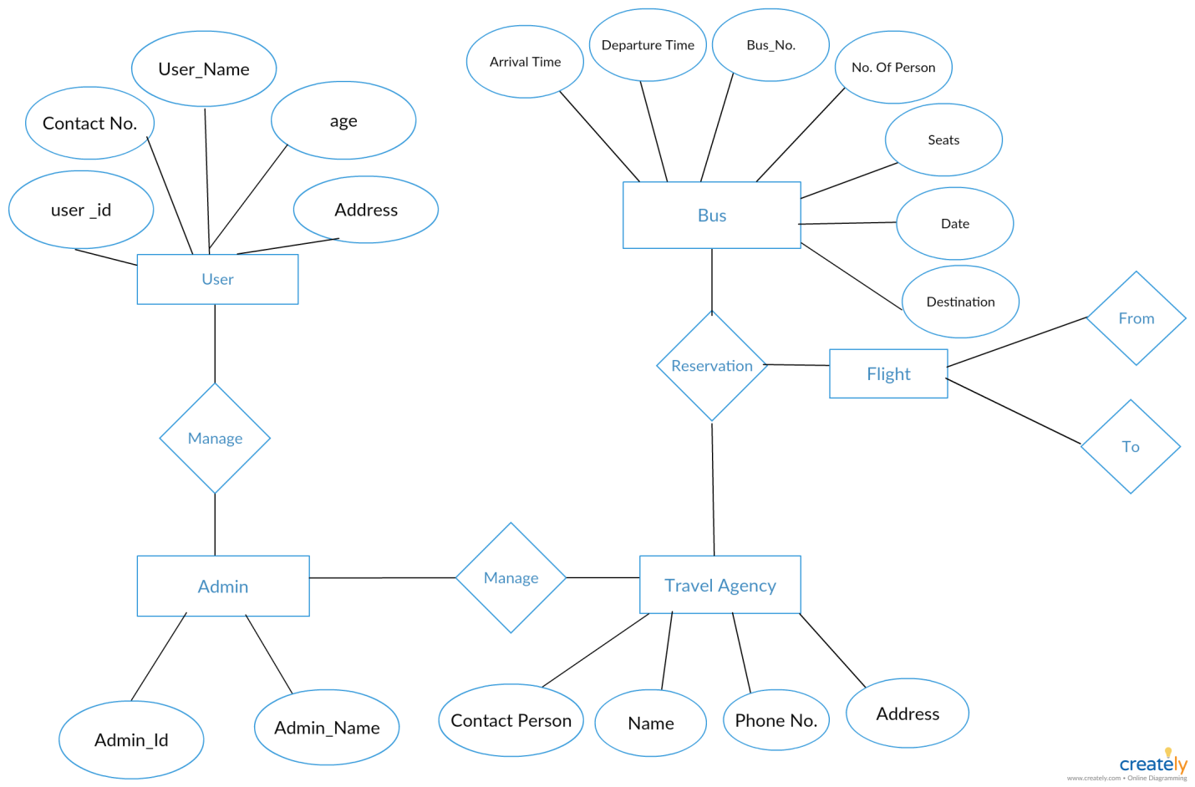

Figure 3.4 ER Diagram

**CHAPTER 4**

|  |  |
| --- | --- |
|  |  |

**TESTING**

**4.1 Theory of Testing**

Software Testing is evaluation of the software against requirements gathered from users and system specifications. Testing is conducted at the phase level in software development life cycle or at module level in program code.

**Black-box testing**

It is carried out to test functionality of the program. It is also called ‘Behavioral’ testing. The tester in this case, has a set of input values and respective desired results. On providing input, if the output matches with the desired results, the program is tested ‘ok’ and problematic otherwise.

**White-box testing**

It is conducted to test program and its implementation, in order to improve code efficiency or structure. It is also known as ‘Structural’ testing. In this testing method, the design and structure of the code are known to the tester. Programmers of the code conduct this test on the code.

**Testing Levels**

Testing itself may be defined at various levels of SDLC. The testing process runs parallel to software development. Before jumping on the next stage, a stage is tested, validated and verified. Testing separately is done just to make sure that there are no hidden bugs or issues left in the software. Software is tested on various levels -

**Unit Testing**

While coding, the programmer performs some tests on that unit of program to know if it is error free. Testing is performed under white-box testing approach.

**4.2 Test Cases**

**Use of Bootstrapping to make Website Responsive**

We have used Bootstrap classes to make some sections of the website responsive so that they can fit to all the screens (Desktop, Tablets & Mobile). Following Sections have Bootstrap classes

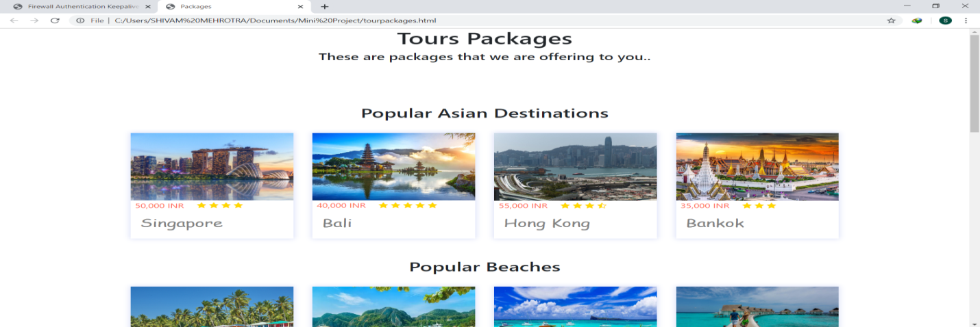

Figure 4.2 On Laptop (width > 768px)

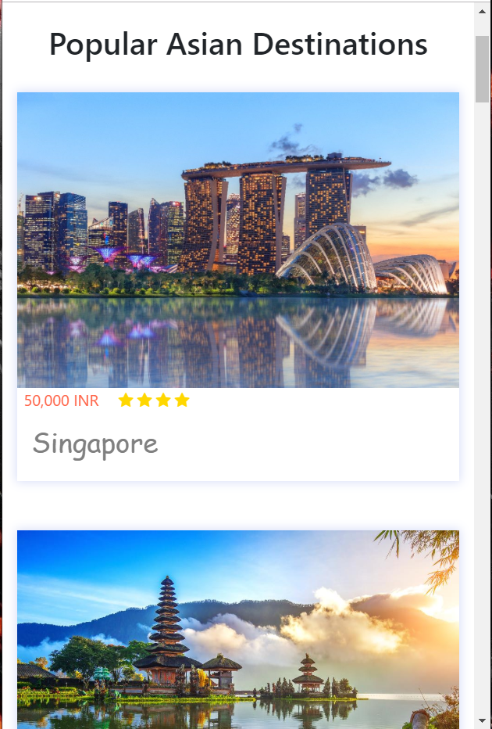

Figure 4.3 For Mobile (width<500px)

**CHAPTER 5**

**USER INTERFACE**

**5.1 Main Page**

The main page which will be visible to every visiting person and this contains all the other sections directly or indirectly.

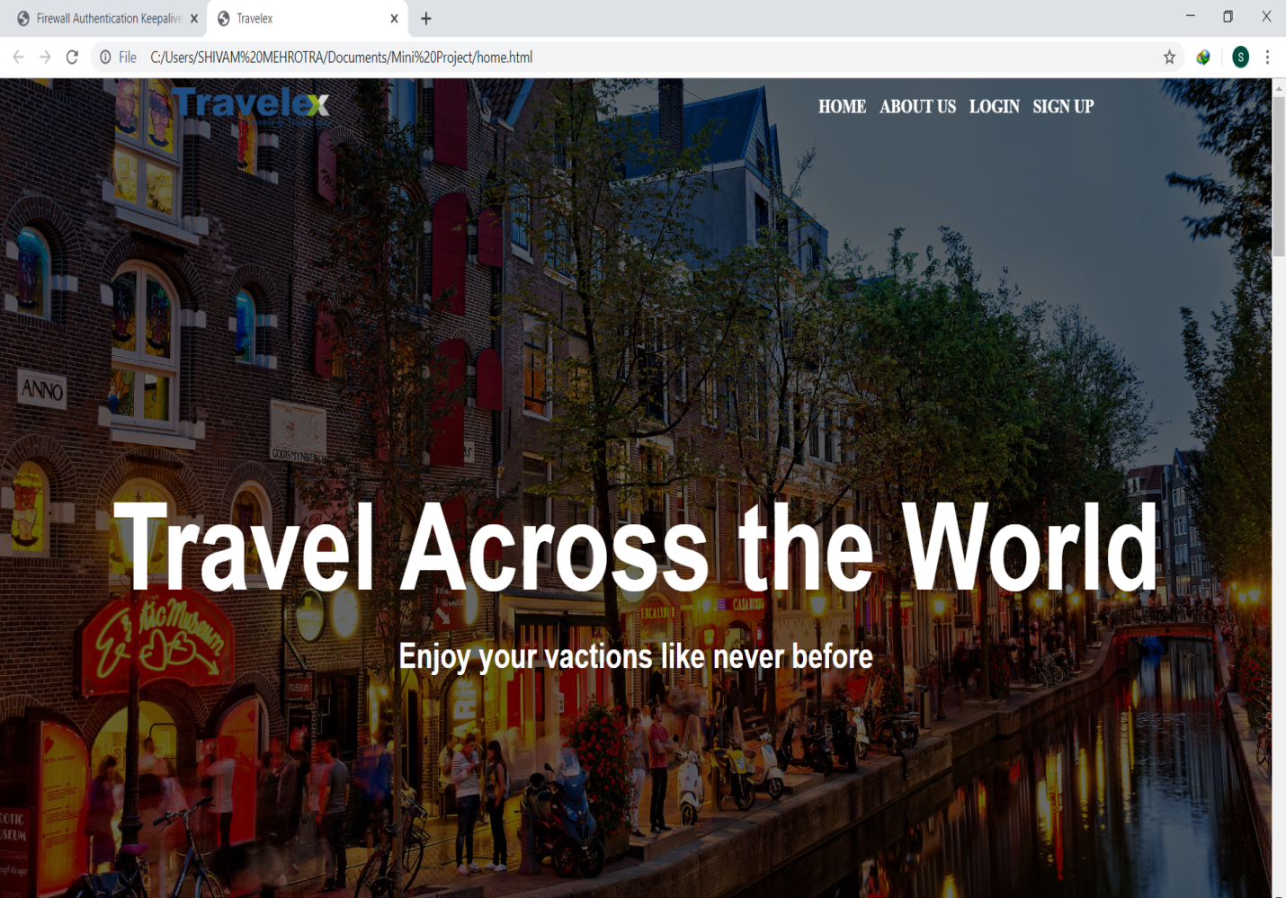

**Figure 5.1 Main Page**

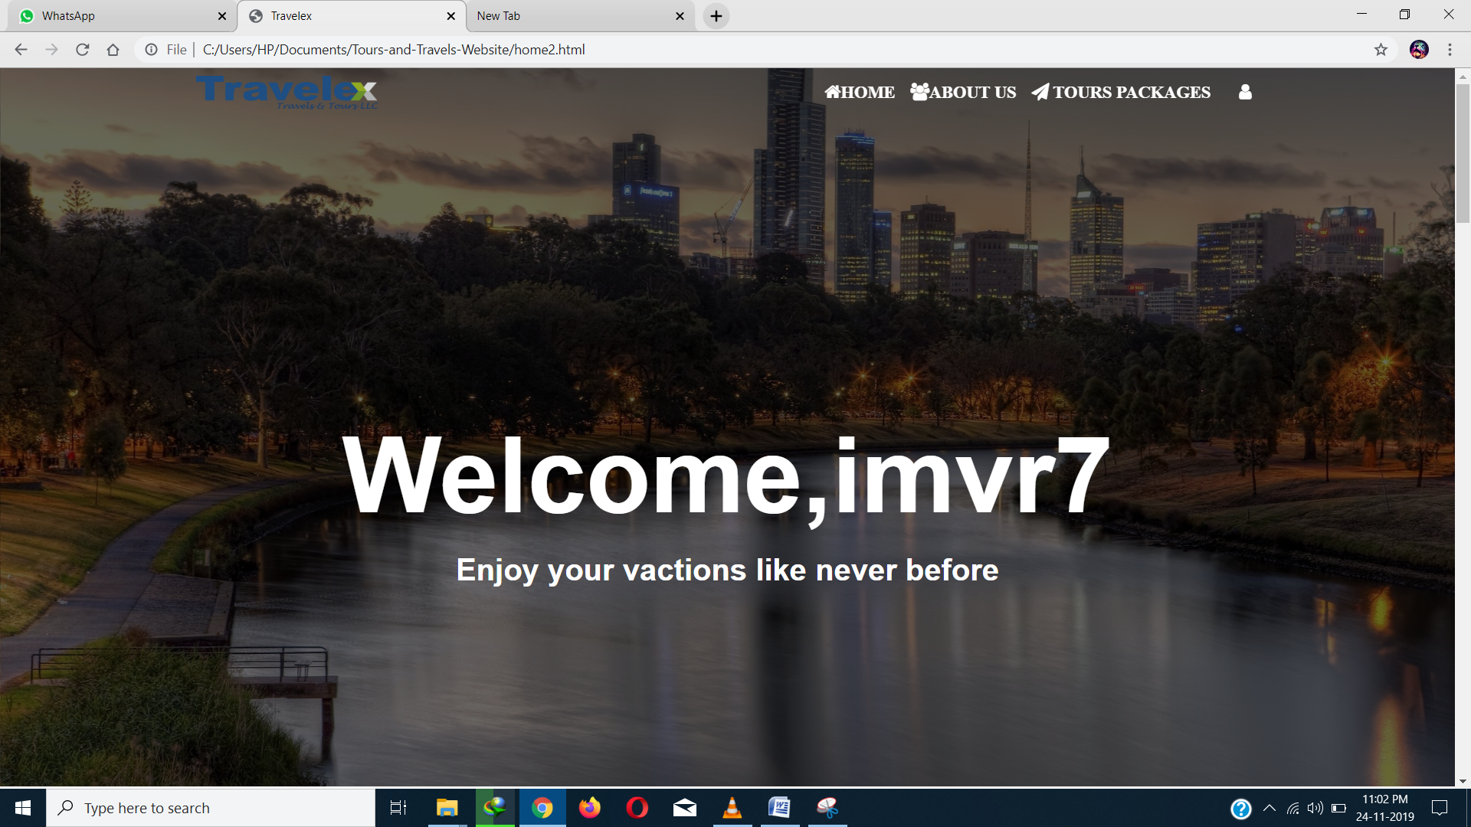

Figure 5.2 Main Page after Login

**5.2 Signup Page**

We have made a Sign Up section which comes when clicked on the Sign Up option given in the navigation bar at the top ,a little of animation is used to show the contents of Sign Up .

On signing in new page loads where there are no options of Sign Up and Login and there is a new option of tour package and a logout option.

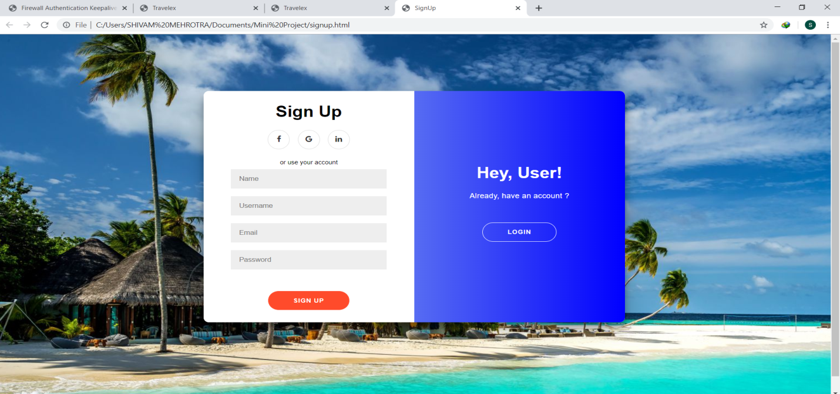

Figure 5.3 Signup Page

**5.3 Login Page**

Made a Login Form which comes when user clicks on the Login Option in the navigation bar. On correctly entering the username and password, user is redirected to the Logged In page where he/she can see his username on the front page of website.

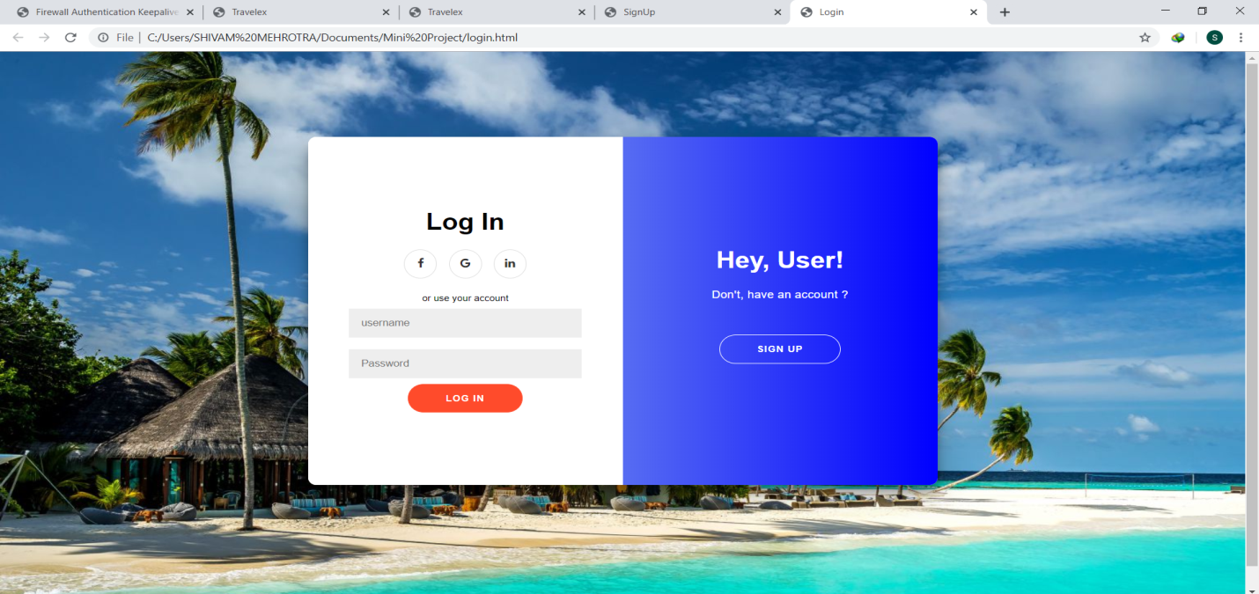

Figure 5.4 Login Page

**5.4 Tour Package Page**

In this Tour Package module, we have added five types of tour as a prototype as to what tour package will look like, User can directly reach the tour package by clicking on the Tour Package option provided in the Navigation Bar after user has logged in on the website.

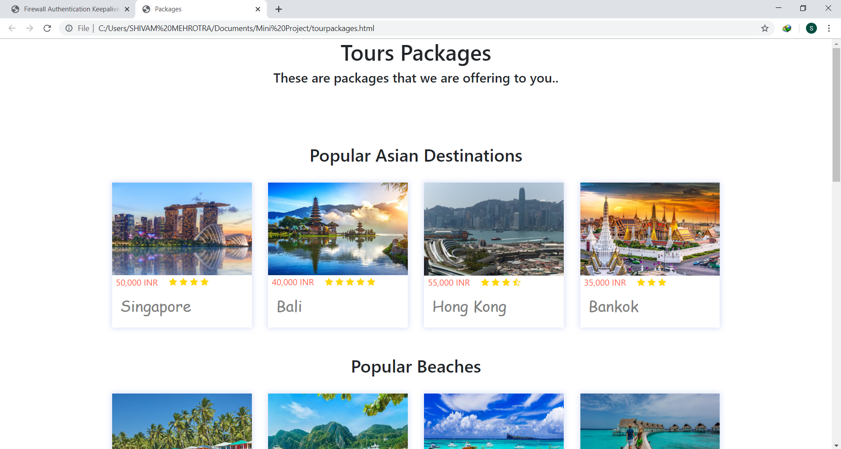

Figure 5.5 Tour Package Page

**5.5 Booking Page**

In this module, user can book a specific tour. In this page user will be given information about our tour to a particular place with the details of hotels in which he will stay during tour and the flights included in his tour. User have to provide the details from which date he wants to travel and up to which. He will also provide how many persons are travelling i.e no. of adults and no of children.

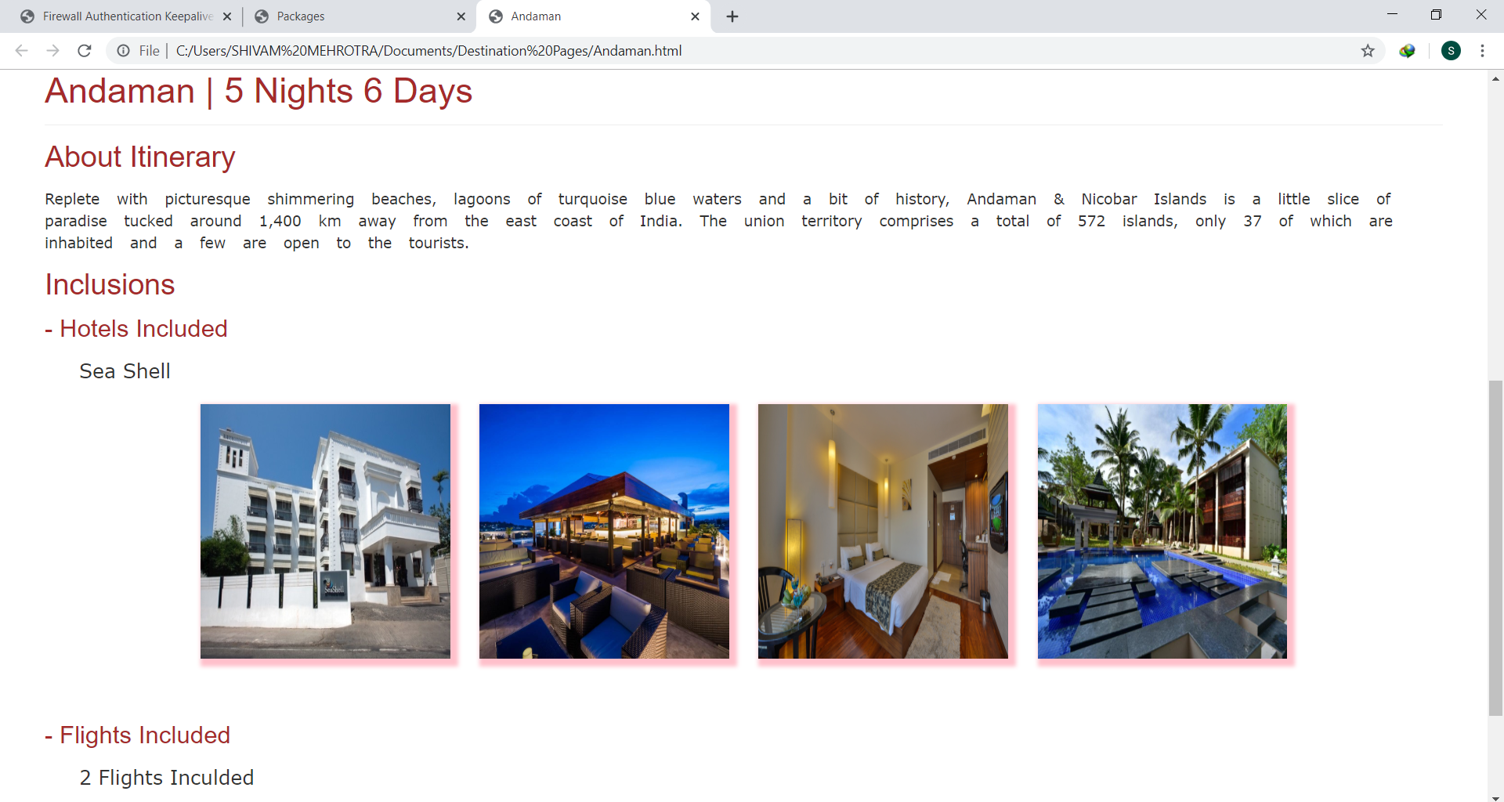

Figure 5.6 Booking Page

**5.6 About Us Page**

Information about the site is given as well as the terms and policies and some other information, User can reach this section by either scrolling or by clicking on the About Us option given in the Navigation Bar.

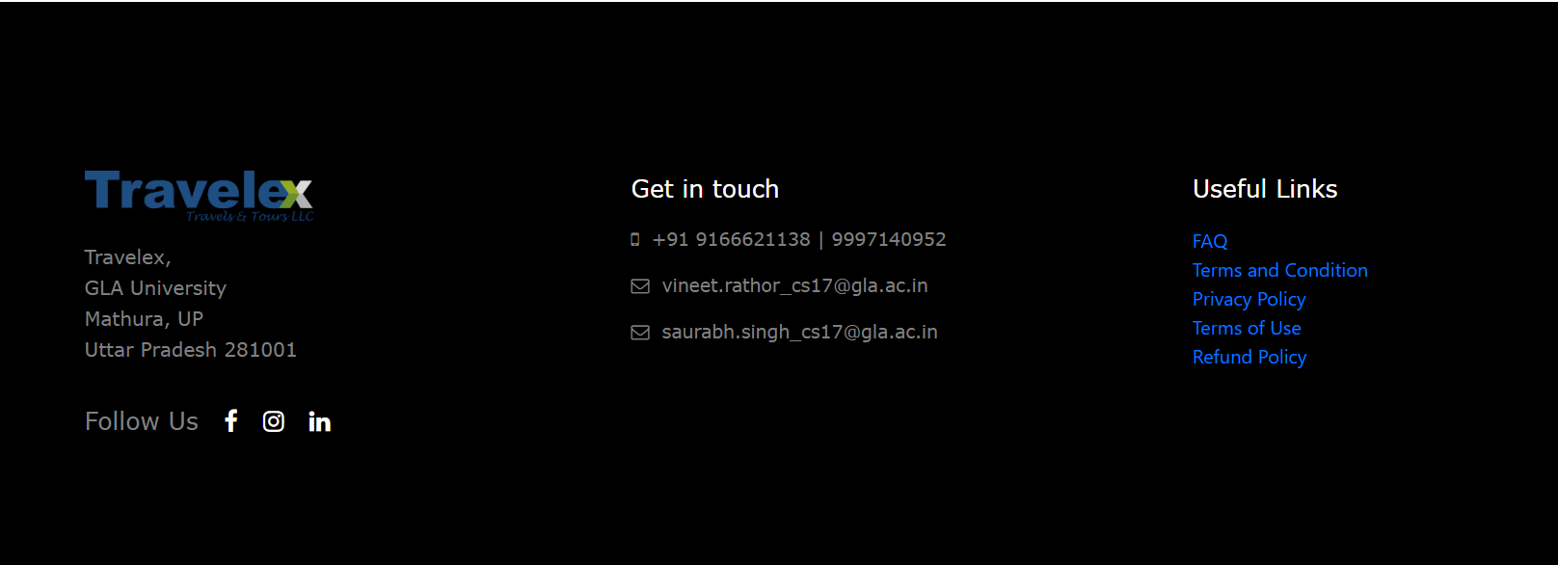

Figure 5.7 About Us Section

**5.7 Payment Page**

User reaches this page on entering the details in the booking section and on clicking the pay button.

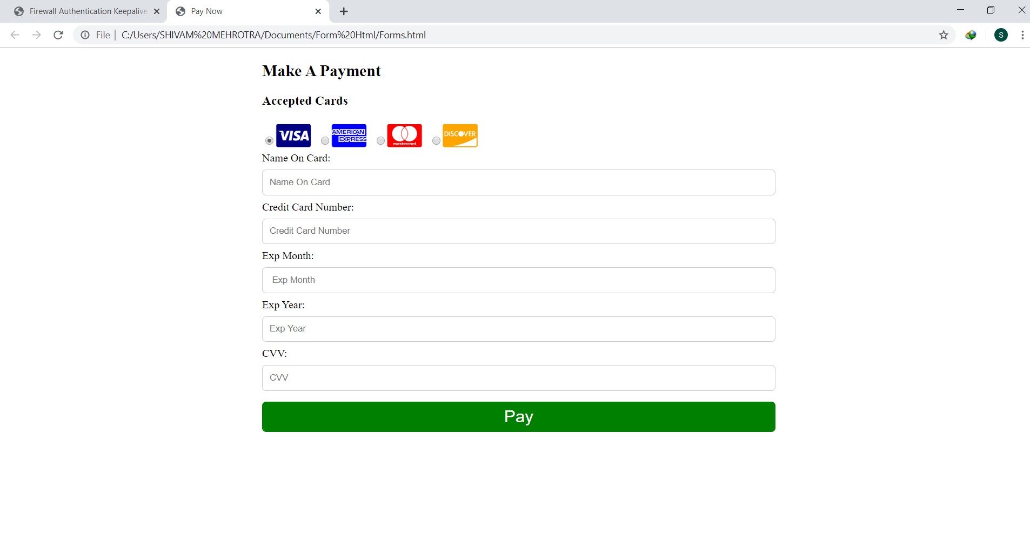

Figure 5.8 Payment Page

**CHAPTER 6**

|  |  |
| --- | --- |
|  |  |

**CONCLUSION**

Tourism is currently recognized as a global industry which is highly growing at a high rate, and like any industry that grows rapidly, the activities of tourism can have a substantial impact on the local development processes. Tours and Travel Website simplifies the management process in travelling. It gives fast processing and immediate results with high security. Navigation through site is easy. It minimizes human effort and is cost efficient. The website automates the processes and activities of a travel agency. In the present system a customer has to approach various agencies to find details of places and to book tickets. This often requires a lot of time and effort. We provide approach skills to critically examine how a tourist visits and its ability to operate in an appropriate way when dealing with the consequences of tourism, locally, regionally, and nationally including visitor security and ecological influences.

**REFERENCES**

1. https://[www.w3schools.com/html/](http://www.w3schools.com/html/)
2. https://[www.w3schools.com/css/](http://www.w3schools.com/css/)
3. https://[www.w3schools.com/js/lt.asp](http://www.w3schools.com/js/lt.asp)
4. https://getbootstrap.com/
5. https://stackoverflow.com